**VILLAGE COMPLAINT MONITORING**

**SYNOPSIS**

This project is “**VILLAGE COMPLAINT MONITORING SYSTEM”** is designed to solve the problem of people and their areas. In proposed system is especially designed for the people and the government. Through this application higher official of government directly monitoring the problem of people because people can post their complaints with their details without any fear then complaint monitoring committee can view the complaint and analyze those complaint whomever responsible to solve that then can forward to solve.

They can response the allocation of that complaint otherwise those complaints forward to their higher official as another complaint like they are not responding or they have no right to take a decision and so on. If the complaint is solved the details are intimated to the respective citizen. Even with each user details should be confidential complaints only forwarded to the solution maker not their privacy information. This project is developed under JAVA and back end server is MySQL.

In existing process is manually conveying their complaints to the responsible person without any recommendation from other higher officials. So lack of perfect response is only can get the result. To tackle this problem, new solution is proposed such that complaint monitoring system. It is developed as website under the direct control of higher officials. This website is developed using JAVA and the back end server as MySQL.

**SYSTEM SPECIFICATION**

**HARDWARE SPECFICATION**

* Processor : P 4 700 GHz.
* RAM : 4 GB RAM
* Hard Disk Drive : 180 GB

**SOFTWARE SPECIFICATION**

* Operating System : Windows 7/8/10
* Front End : JAVA
* Back End : SQL

**MODULES**

1. **New Citizen Registration**

This module the citizens are manually visit the page and give the details and register manually. We can collect the citizen some unique and important information from this application. Once the request has been submitted the admin can handle the approve.

1. **Apply Complaint Request**

After the login for citizen, raise the complaint we just collect the issue as complaint and raised the issue. This notification will send to the admin portal. Can also check the status of the current process of the issue.

1. **View Complaints**

Once the admin portal has been viewing the requested information is completed, then admin changed the status of the process. We can check the admin status as a point of important time.

1. **View All citizen details**

Admin can check the citizen details in the portal, only admin can see the details of the other citizen, only citizen can check the profile itself.

1. **Apply request actions**

Once the admin gets take an action for the issue, has to change the status as in progress, completed. Which mean user can easily identify the status of the issue,

**Data Flow Diagram / USE Case Diagram**

**LEVEL 0**

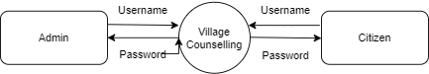

**Level 1**

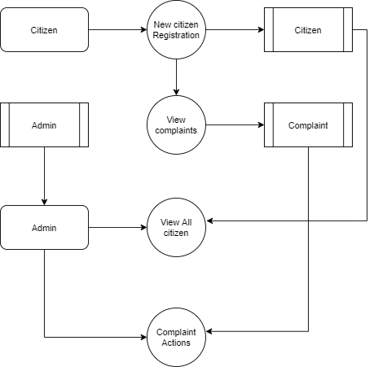

**ER Diagram**

